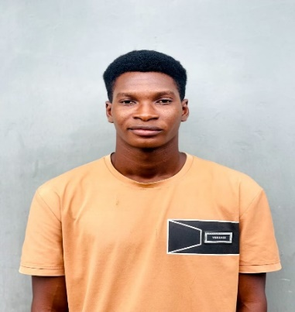

DAVIS OJISI

* **CONTACT: 09069185125**
* **GMAIL: OJISIDAVIS@GMAIL**
* **LOCATION: BENIN CITY EDO STATE**

SKILLS

* HTML
* CSS
* JAVASCRIPT
* PHP

LANGUAGES

* ENGLISH

**EDUCATION**

* Designed and developed user-friendly website.
* Designed an optimized check-page that increased user clicks and subsequently customer purchases

By 20%.

* Collaborate with client to ensure 100% satisfaction.

**FREELANCE WEB DEVELOPER**

Self-Employed

**2021 - PRESENT**

EXPERIENCE

* UNDERGRADUATE MECHANICAL ENGINEERING, 2021-2026
* FEDERAL UNIVERSITY OF PETROLEUM RESOURCES EFFURUN

**DDL**